Grandson(Babka-sraka)

DESIGN DOCUMENT)))
By GAKURO And DEN for the 2024 First AKADev Studio Game Development

Introduction 2
Game Summary 2
Inspiration 2
Player Experience 2
Platform 3
Development Software 3
Genre 3
Target Audience 3
Concept 3
Gameplay overview 3
Theme Interpretation 4
Primary Mechanics 4
Secondary Mechanics 5
Art 6
Theme Interpretation 6
Design 6
Audio 7
Music 7
Sound Effects 7
Game Experience 7
UI 7
Controls 7
Development Timeline 8

Introduction

Game Summary Pitch
Grandson is a first-person horror game about a boy visiting his grandparents out of the city from whom he hasn’t heard anything in a wile, however when he arrives at the village he has to unravel what happened here and face Chthonic horror that his grandparents have become.

Inspiration
Nun massacre
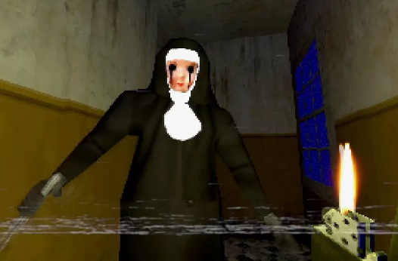
NIGHT OF THE NUN (2018) - A letter has arrived at your house under mysterious circumstances... your daughter has fallen ill at her boarding school. As you make a trip to pick her up, a storm blows in and the road is blocked. You continue on foot through the woods and all hell soon breaks loose...

Hide from the PSYCHOPATHIC nun at all costs! She hungers for BLOOD and you are the next course! Nothing could prepare you for a NUN MASSACRE! Terrifying ps1 style stealth horror.

Stealth horror gameplay. It's a DEADLY game of Hide and Seek!
5th gen graphics. It looks like a lost Playstation 1 game!
Pick your preferred image format - VHS, black & white or psx
There are multiple endings and secrets to unlock in the NUN'S nightmarish lair
Vnuchek
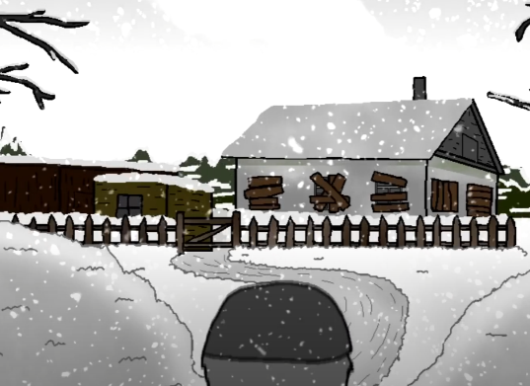
Vnuchek is a short parody/comedy/horror story from which the main inspiration of a story comes.
(https://www.youtube.com/watch?v=ACPz6tM8Pfw).
The color out of space
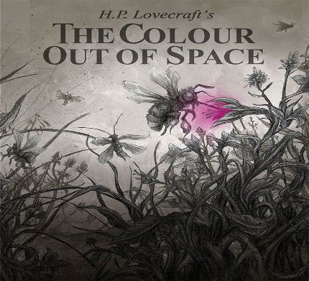
The color out of space is a science fiction/horror short story by American author H. P. Lovecraft, written in March 1927.^{[2]} In the tale, an unnamed narrator pieces together the story of an area known by the locals as the "blasted heath" (most likely after a line from either Milton's Paradise Lost or Shakespeare's Macbeth)^{[3]} in the hills west of the fictional town of Arkham, Massachusetts. The narrator discovers that many years ago a meteorite crashed there, poisoning every living being nearby: vegetation grows large but foul-tasting, animals are driven mad and deformed into grotesque shapes, and the people go insane or die one by one.

Player Experience
Arriving at the village location the player will face one of the antagonists the grandpa, the player will be followed by him hiding and running while solving puzzles progressing deeper into village location underground unraveling the story of what happened while gathering items required to progress navigating various locations.

Platform
The game is developed to be released on windows PC

Development Software
- Unreal Engine
- Aseprite for UI
Blender for graphics
- FL Studio 20 for all music and SFX

Genre
Singleplayer, psychological horror, Surviving horror, investigation, retro, Gore, violent, first person, body horror.

Target Audience
With interesting mysterious story and violent, gory scenes this game is targeted at those who enjoy old school lavcraftian chthonic fear

Concept

Gameplay overview
The game is first person horror, starting the game the player has his cell phone and keys from the gates of the village territory which he uses to enter, after confronting the grandpa the player loses the keys and now can’t get out, the only way to escape the grandpa is deeper into the village, while navigating the village evening slowly turn into the night, the player can use his cell phone as a flashlight however the light is not effective, we can explore different houses finding notes and evidence of what happened here and also finding useful items which can help us progress further, being chased by grandpa deeper into the village, we start seeing weird horrifying visions of flesh, through the woods we find weird entrance into the underground mines, finding more and more moaning corpses which look like husks connected through the net of flesh, deeper in the mine we find our grandma who looks okay on the first glance but then revealed to be a massive mass of flesh consisting of other villagers now being chased by both grandparents we find an opening in the mine where we discover a weird unknown alien obelisk which was mentioned in some of the notes we found, it sits on the altar and seems to be the cause of everything,(In the notes we find that mining was started recently and miners found the obelisk deep underground, the obelisk crashed on earth million years ago, we find about it either through notes or visions, maybe some of the infected gives us some clues about the lore) in the mines we find more notes and evidence of how the obelisk was found by the villagers and driven them mad draining them, changing them, making them part of it self, the closer we are to the altar the more visions we get, grandma was changed by the obelisk and was feeding those who survived to it building the everlasting altar of flesh to the obelisk, on our way we find various weaponry, antic guns and a rifle, however they are ultimately useless against them but at least they can stagger the grandpa giving you a little bit of breathing room, guns do not work on grandma, we find items to craft a flamethrower and molotov’s cocktails, and they seem to work on grandpa, we have a little boss fight where grandpa uses tentacles of flesh to get us while we burn him, killing the grandpa we claim our keys and try to make an escape, grandma still chasing us trying to fight her with a flamethrower seems to scare her away and we escape the mines running to the gates through the village, however grandma catches up to us and isn’t effected by the flamethrower, she kills us with a screamer and then we see a calming vision of us spending time with the grandma however the vision is fading as we discover we are now the part of the obelisk, unable to die doomed for eternal pain and misery, in praise of the pain, in praise of the flesh, in praise of the obelisk… game ends.

Theme Interpretation

Primary Mechanics

Secondary Mechanics

Art

Theme Interpretation

Design

Audio

Music

Sound Effects

Game Experience

UI
.

Controls
Keyboard
Arrow keys / WASD
Gamepad
Dpad

Development Timeline

MINIMUM VIABLE PRODUCT

BEYOND (if ahead of schedule / extra time)

